**Ideation Phase**

**Brainstorm & Idea Prioritization Template**

|  |  |
| --- | --- |
| Date | 31 May 2025 |
| Team ID | LTVIP2025TMID43861 |
| Project Name | Transfer Learning-Based Classification of Poultry Diseases for Enhanced Health Management |
| Maximum Marks | 4 Marks |

**Brainstorm & Idea Prioritization Template:**

In this phase, we explored various ideas to solve the challenge of early poultry disease detection. By combining the team’s expertise in AI, mobile development, and veterinary science, we brainstormed solutions like AI-powered image classification, mobile app integration, and treatment recommendations. These ideas were then grouped and evaluated for impact and feasibility.

Reference: <https://www.mural.co/templates/brainstorm-and-idea-prioritization>

**Step-1: Team Gathering, Collaboration and Select the Problem Statement**

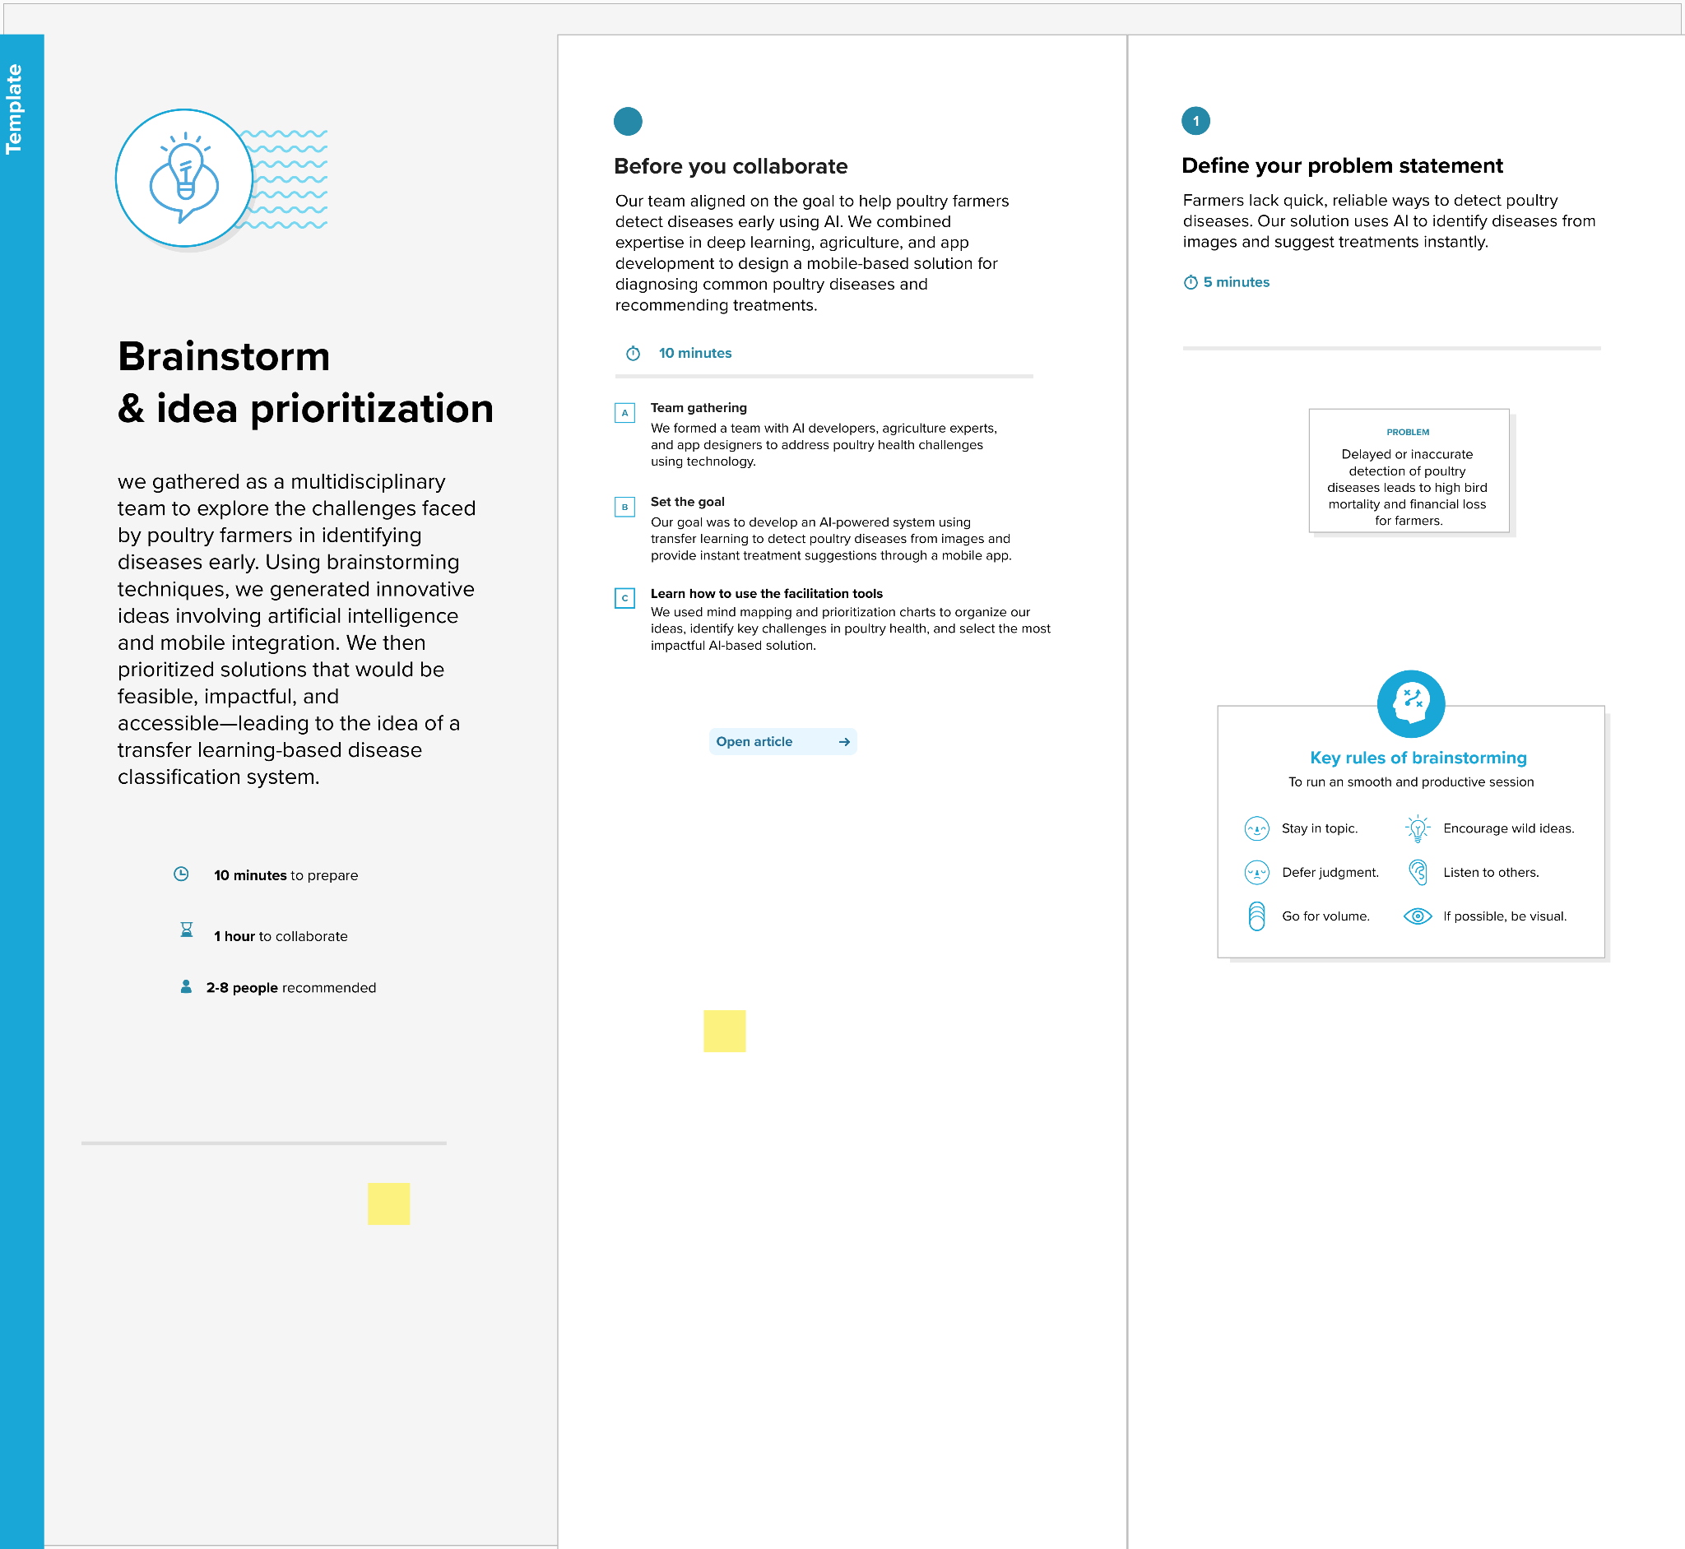

**Step-2: Brainstorm, Idea Listing and Grouping**

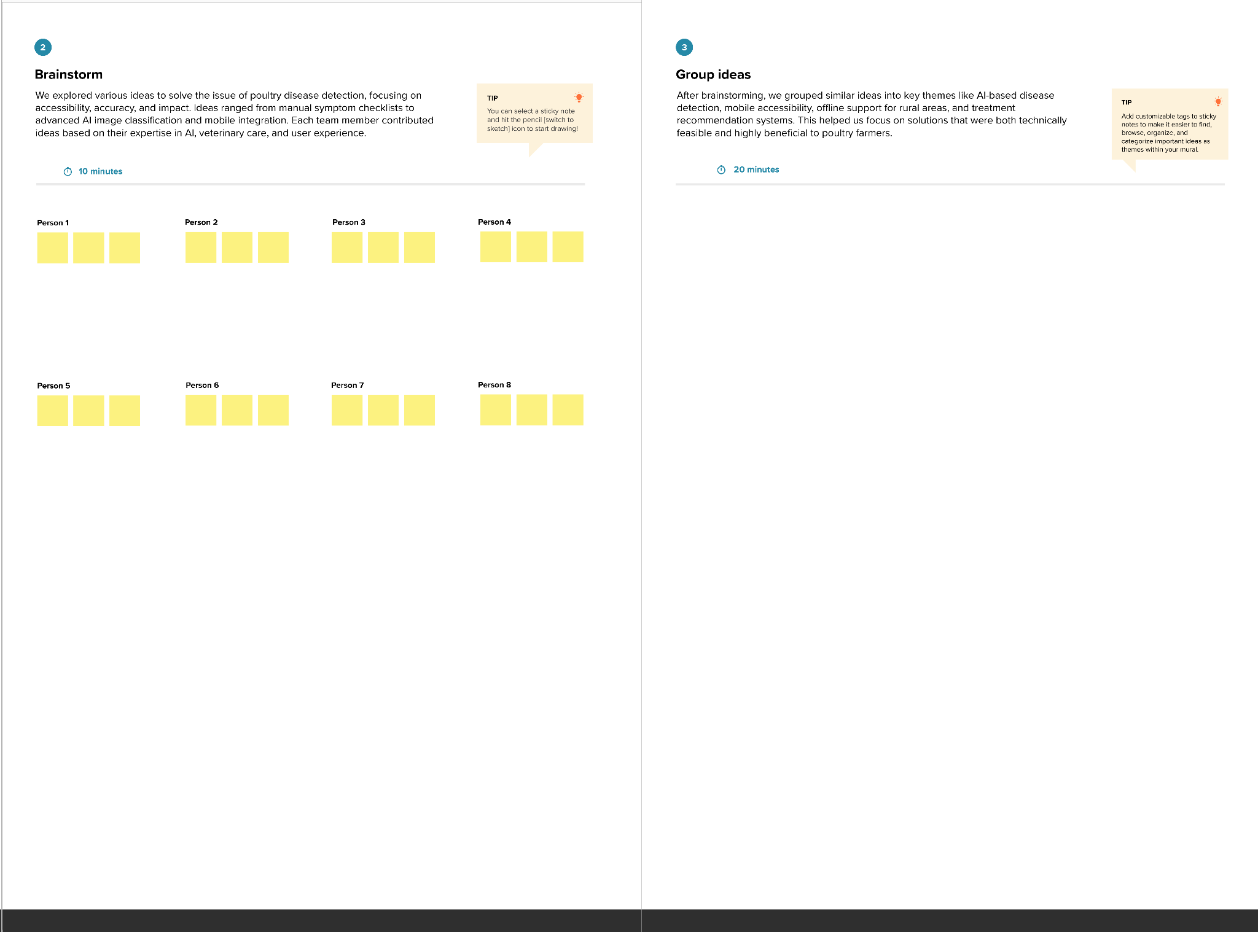

**Step-3: Idea Prioritization**

